

Sonar lint

**SonarLint for Eclipse — Proactive Code Quality Checks**



Table of Contents

Jan. 3, 2017

**Rohit raj**

rohit@pragiti.com

|  |
| --- |
| 1. **About SonarLint** |
| 1. **Features of SonarLint** |
| 1. **Pre-Requisite to install SonarLint** |
| 1. **Running SonarLint** |
| 1. **Feedbacks by SonarLint** |

**What is SonarLint? Why to use SonarLint?**

**SonarLint** is an Eclipse plugin that provides on-the-fly feedback to developers on bugs and quality issues injected into Java, JavaScript and JSP code.

**Features:**

SonarLint offers a fully-integrated user experience in Eclipse-based IDEs. After installing the plugin issues will be reported as Eclipse markers.

SonarLint is free, open source, and available in the Eclipse Marketplace.

**Integrate SonarLint with Eclipse**

**Pre-Requisite:**

You need to download

1. **Eclipse**

**Eclipse Sonar Plug-In Installation**

**Eclipse Integration (To install this plugin in the Eclipse IDE) - With Eclipse Market Place**

**Step 1:** For Installing SonarLint Plugin from eclipse, select **Help**->**Eclipse Marketplace.**

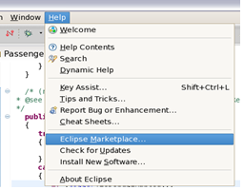

*Figure 1 – Sonar Lint Eclipse Plug-in Install (Market Place)*

**Step 2: Type Sonar, this should display the Install dialog box.**

2.a) Select the solutions from the install dialog box

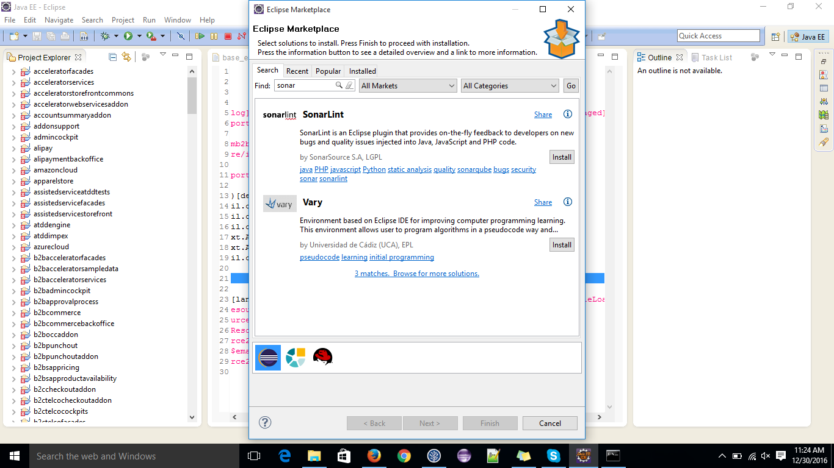

*Figure 2 - Sonar Eclipse Plug-in Install (Market Place) II*

A list of available plugins and components will be displayed

**Step 3: Select the features and click Next.**

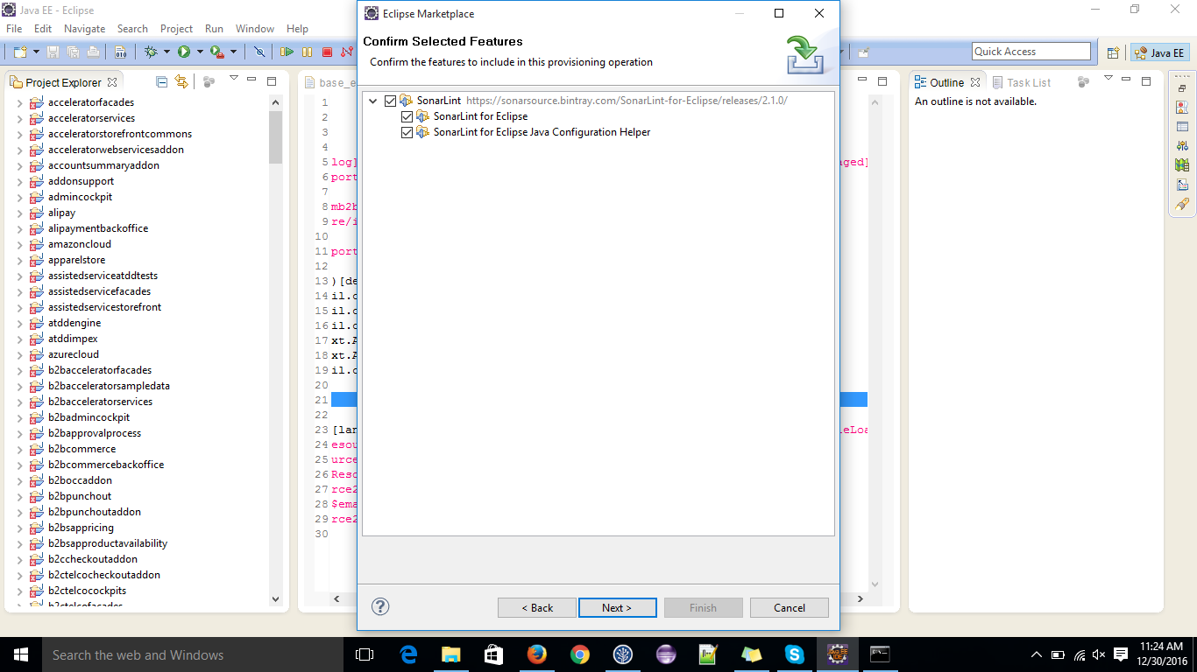

*Figure 3- Sonar Eclipse Plug-in Install (With Install New Software Menu)*

**Step 4: Finish the installation**

Accept the agreement and click finish

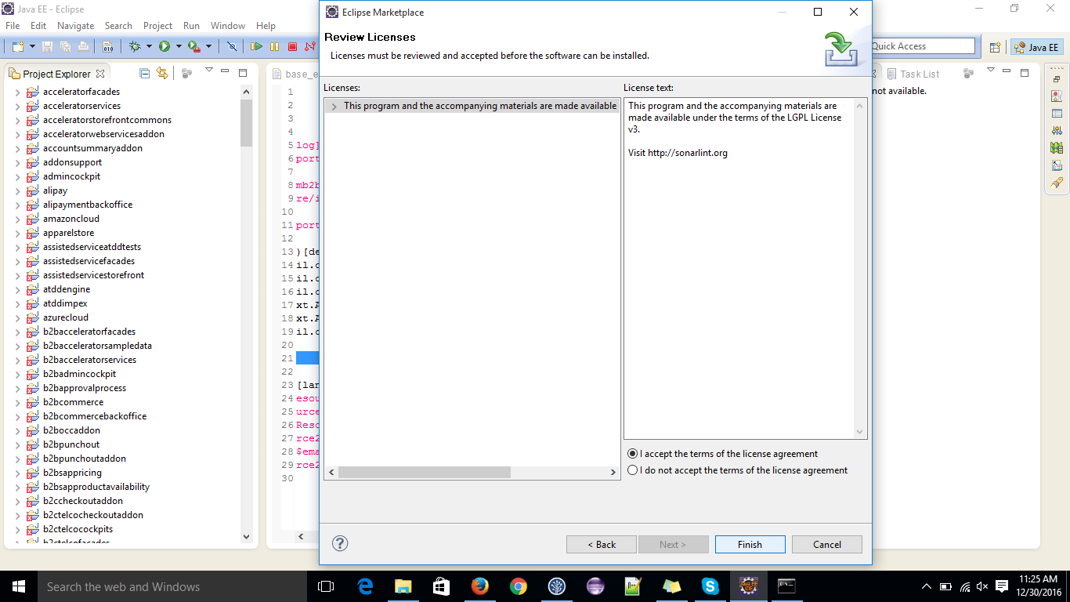

*Figure 4 - Configure Sonar Lint in Eclipse*

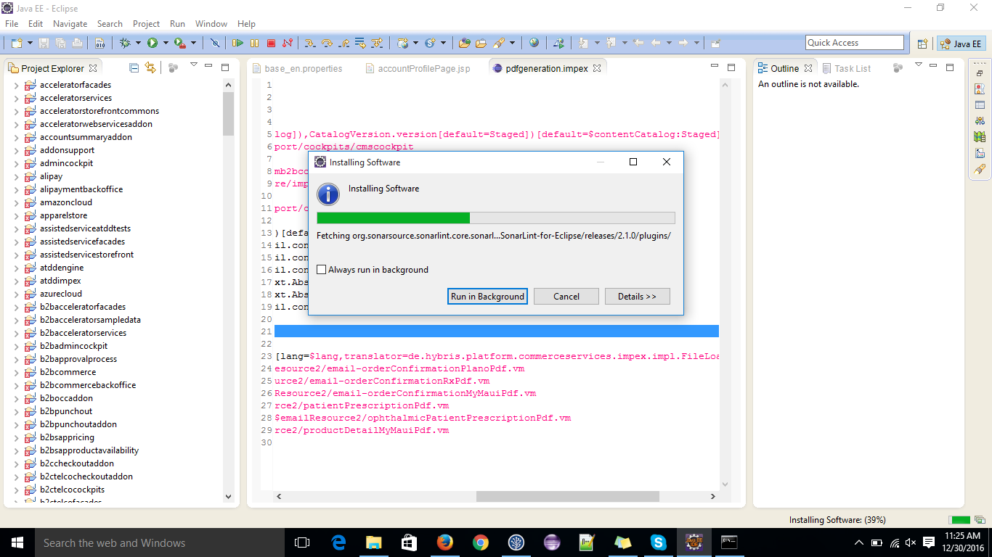

*Figure 5 -*  Installing Software

## **Running Sonar Lint**

Then, Build the project using **Project**->**Build Project**. Right click on the project, and run the Sonar lint according to following screenshot.

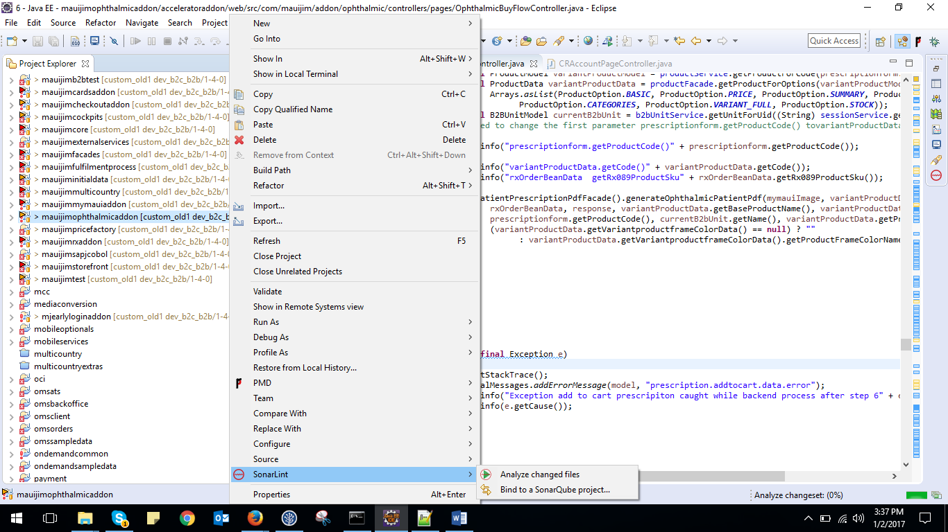

*Figure 6- Configure the Sonar Lint to analyze the code*

**Now work on the feed backs provided by the SonarLint**

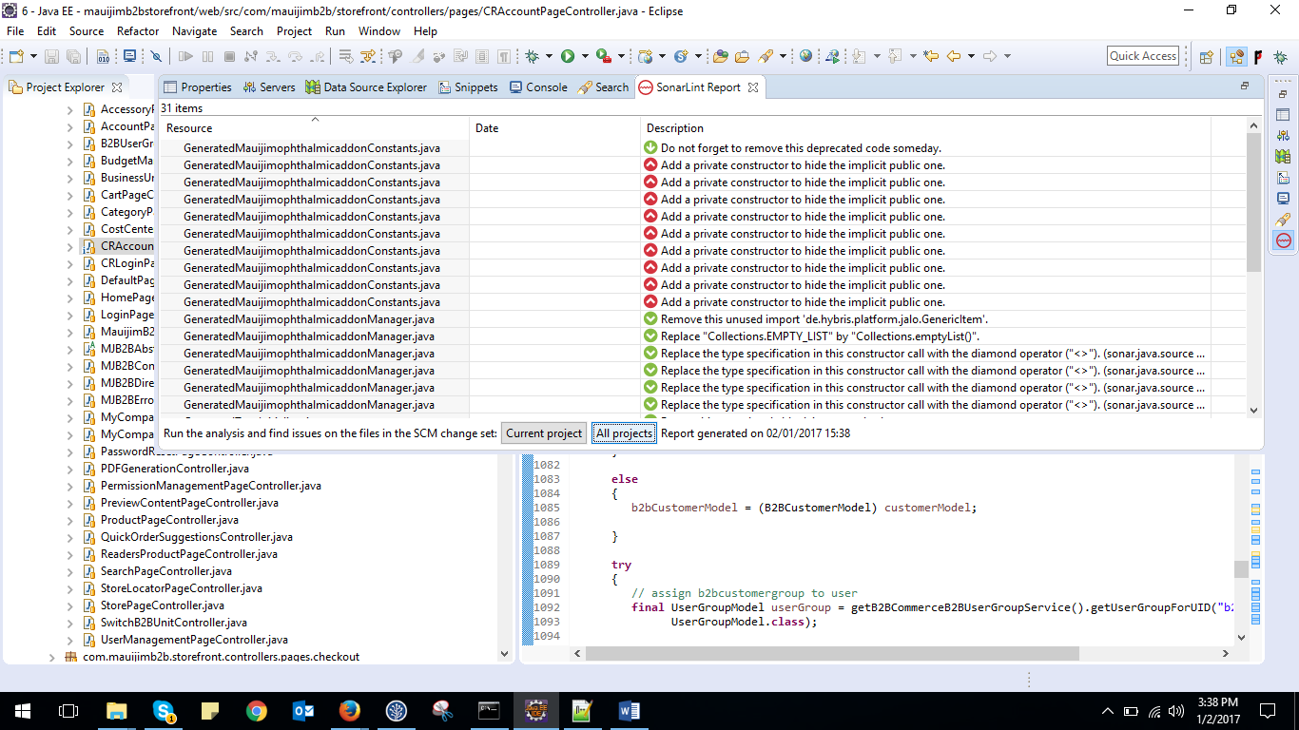

Figure 7: Code Suggestions in the Solr Lint window.

Thank you!